Report on World Mental Day observation in Calicut
Psychiatry department of IQRAA International Hospital and Research Center at Calicut in association with World Federation of Mental Health, World Association for Psychosocial Rehabilitation, World Association for Psychosocial Rehabilitation – Indian Chapter, Indian Medical Association – Calicut Chapter and Kerala Federation of the Care of Mentally Disabled observed World Mental Health Day on 10th October 2008 at Town Hall in Calicut district, Kerala. The theme of this public awareness programs was “Role rehabilitation in psychiatric disorders”.
Dr.P.N.Sureshkumar, Consultant Psychiatrist welcomed the gathering and Dr.P.C.Anwar, Director IQRAA International Hospital and Research Center presided the function. The programme was inaugurated by Srimathi Sugathakumari, a well known poet and social activist working in the filed psychiatric rehabilitation in Kerala. Sri. C. P.. Kunhammed Master, President of Calicut District Panchayath inaugurated the new rehabilitation center “Chethana” a center giving free rehabilitation services. Dr.T.Murali, Vice president of World Association for Psychosocial Rehabilitation delivered key note address on the need for rehabilitation in psychiatric disorders. .Dr.V.K.Radhakrishnan, General Secretary of World Association for Psychosocial Rehabilitation delivered a talk on the present scenario of psychiatric rehabilitation in Kerala. Mis Ahalya Pavithran, occupational therapist from Ansar Hospital, Perumbilav was created a new awareness about the role of occupational therapy in psychiatric rehabilitation.
Dr.John Erik Berg, Consultant Psychiatrist from Norway, Dr.P.N.Sureshkumar, Consultant Psychiatrist from Calicut, Dr.Pfizer, Consultant Psychiatrist from Trichur, Mr.Santhosh Joseph, Director of Mariya Sadanam rehabilitation center from Kottayam and Mr. Johny,Jyothi Nivas rehabilitation Centre from Wayanad shared their experience in the filed of rehabilitation.
Along with this programme there was an exhibition of prominent rehabilitation centers in Kerala and eighteen centers from different parts of Kerala displayed their various products and activities in each stall. This programme was well attended by more 1000 people from all walks of life including patients, relatives, social workers, public health nurses and like minded people. This was very good coverage about this programme in news papers, radio and television channels.

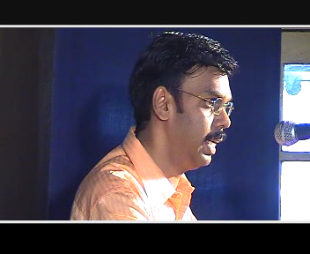

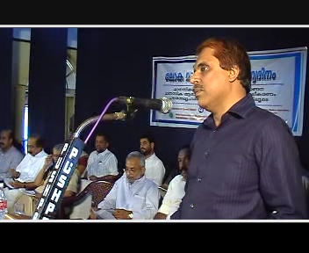
welcome addressDr.P.N.Sureshkumar-

Presidential address - Dr.P.C.Anwar

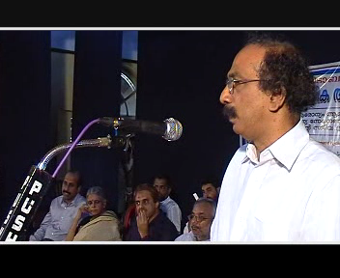
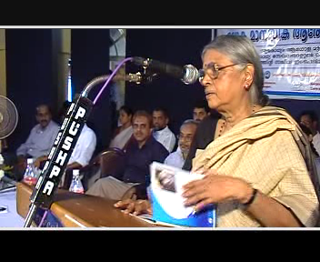
Inauguration of new Rehabilitation Centre - Mr.K.P.Kunhammad Master
Inauguration of the public awareness programme - Srimathi Sugathakumari
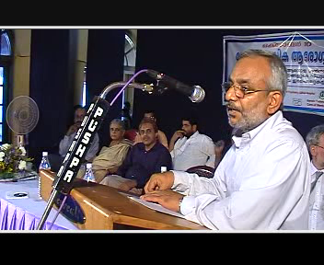
Keynote address - Dr.T.Murali
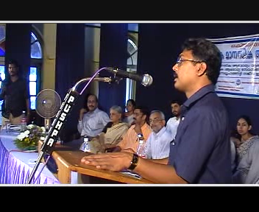

Mr.Santhosh Joseph –sharing the experience of rehabilitation
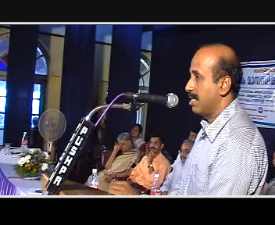
Present scenario of rehabilitation in Kerala- Dr.V.K.Radhakrishnan

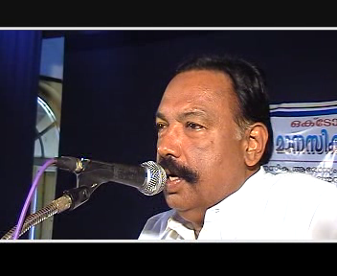

Felicitation-Mr.Chaley Pala
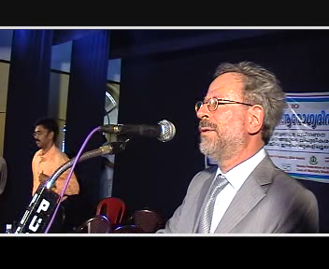
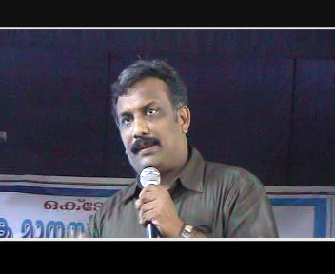
Dr.John Erik Berg –sharing the experience of rehabilitation
Dr.Pfizer–sharing the experience of rehabilitation

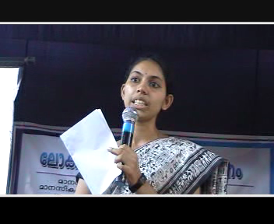
Mis.Ahalya Pavithran- role of occupational therapist in rehabilitation
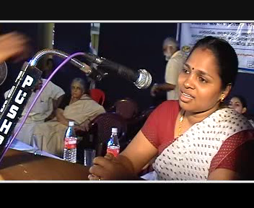

Mrs Sreeja- Felicitation
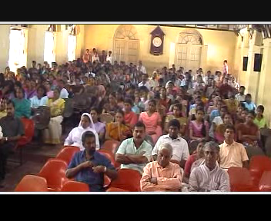

Audience.

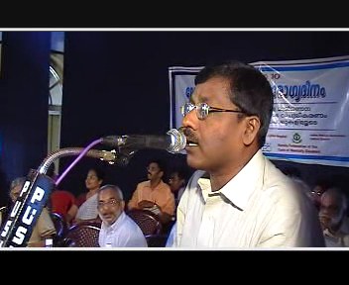

V.T.Murali Notes Malayalam singer ,Singing a song
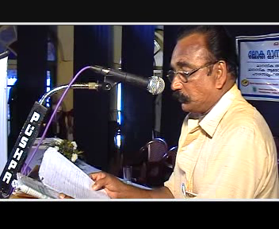

Vote of Thanks – Mr.Jayaprakash

