iii) The WMHD Commemoration Event
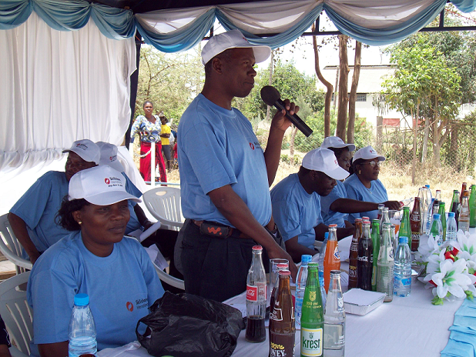
The RMO gives a speech from the high table.
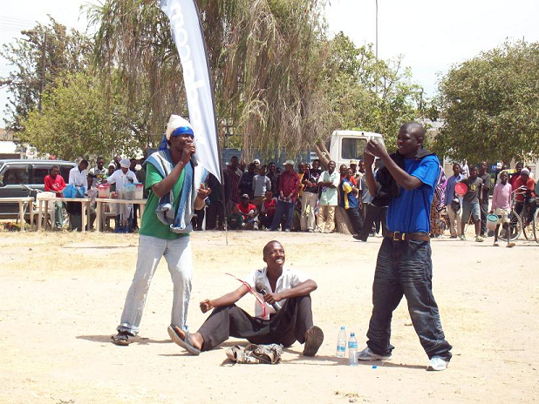
A drama about the risks of using illegal drugs is watched by members of the public.
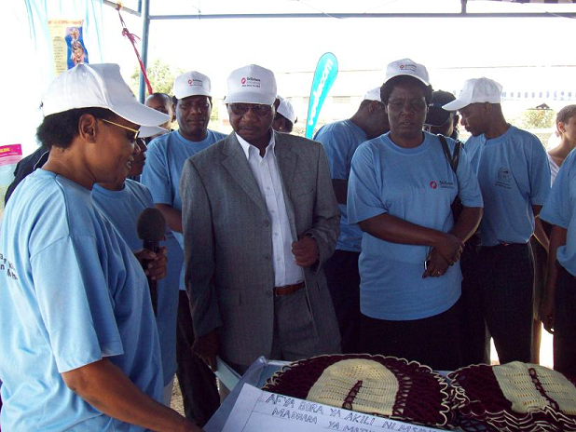
The DC of Dodoma Municipal is given a tour of the Information Tent and judges a poster competition.
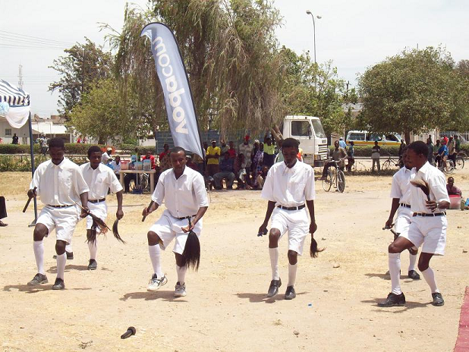
A Ngoma Troupe performs music and dance around the WMHD theme.

