ii) The WMHD March
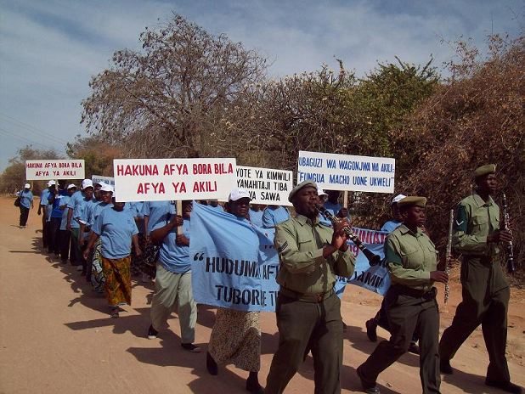
The March starts from Mirembe Hospital with a brass band leading the marchers.
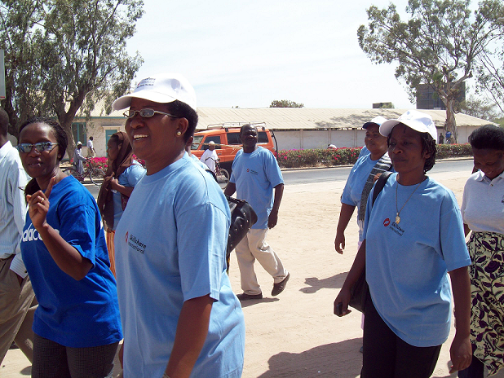
The marchers are in good spirits – members of the public, health workers and committee members.
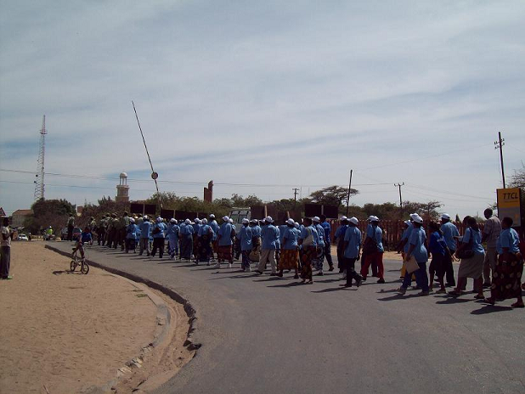
The march progresses through Dodoma town centre, stopping traffic as it goes.

