APPENDIX 4
i) Community Sensitization at Makang’wa village
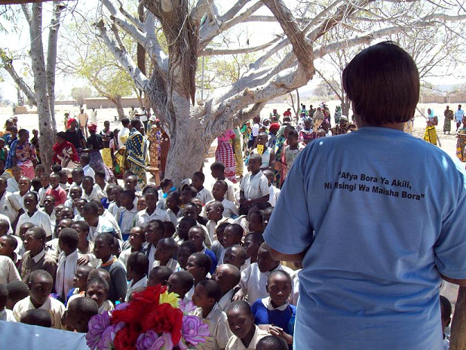
Dr Fileuka disseminates the WMHD theme.
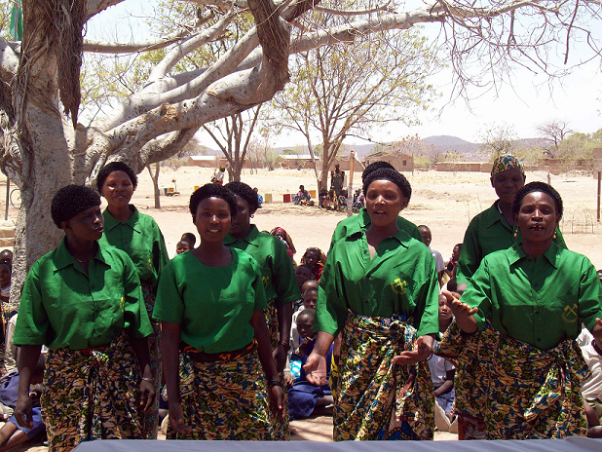
The Makang’wa Ngoma Troupe performs a special WMHD song.
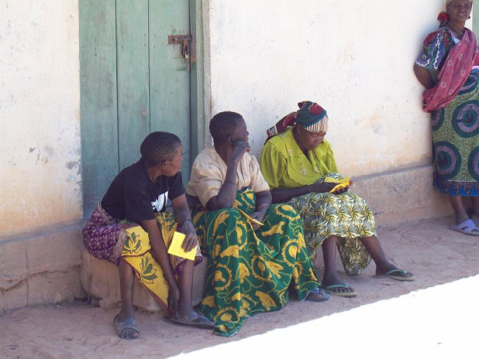
Residents of Makang’wa read leaflets about mental health.

